

Design document

OutSports

An application to facilitate the safe practice of sports in a group.

Software engineering 2020-2021

Erasmus Group:

Inês Santos 884840

Nuno Nogueira 884842

Rui Ramos 884843

Index

1 Introduction 4

1.1 Purpose of the document 4

1.2 Structure of the document 4

2 Glossary 5

3 System Structure 6

4 Control Model 6

5 Class Diagram 7

6 Activity Diagram 8

6.1 View profile 8

6.2 Change settings 9

6.3 View past activities 10

6.4 Start activity 11

6.5 View activity on the map 12

6.6 Join a group 13

6.7 Make a group 14

6.8 Leave the group 15

6.9 View teammates account 16

6.10 Expel teammate 17

6.11 Start activity in a group 18

7 Sequence Diagram 19

7.1 Track Exercise 19

7.2 End Activity 20

7.3 View Account 20

7.4 Activate/Deactivate Features 21

7.5 Make a Group 21

7.6 Join a Group 22

7.7 Leave a Group 22

7.8 Add Teammate 23

7.9 Expel Teammate 23

7.10 Consult Past Activities 24

7.11 View Teammate’s Account 24

8 Graphic Interface 25

8.1 Map options 25

8.2 Group options 26

8.3 Statistics options 27

8.4 Profile 28

8.5 Make a group 29

8.6 Join a group 30

8.7 Group activity 31

8.8 View Teammate’s Account 32

8.9 Tracking activity 33

# Introduction

## Purpose of the document

The purpose of this document is to describe the structure and operation of the app.

A series of diagrams will also be provided, the purpose of which is to provide, quickly and intuitively, to understand the way our app works.

## Structure of the document

This document is divided into the following parts:

• **Glossary**: ​​This is a detailed list of technical terms used in the document, useful to ensure the understanding of the text by any type of user.

• **System structure**: in this section we will show how the system is structured, highlighting the subdivision into subsystems and showing how they communicate with each other.

• **Control model**: the purpose of this paragraph is to illustrate the chosen control model

to establish the relationships between the identified subsystems.

• **Class diagram**: this is a section aimed at describing the entities that constitute the system and their relationships, also showing the various operations that can be carried out.

• **Activities diagram**: the activities that need to be performed will be defined here to implement the features offered by the application.

• **Sequence diagram**: here will be shown, concerning the various activities described, the function calls.

• **Graphic interface**: this section will illustrate the prototypes of the graphic interface intended, showing the most important schemes.

# Glossary

**Software**: Software is a set of instructions that must be followed and executed by a mechanism, be it a computer or an electromechanical device. It is the generic term used to describe programs, apps, scripts, macros, and instructions for directly embedded code.

**App**: Short for application, or software program intended for an end-user. The term is usually used regarding mobile terminals.

**API** (Application Programming Interface): An API is a set of programming code that enables data transmission between one software product and another. Their usefulness is especially to reuse code already implemented by the company that created the platform itself.

**Android**: an operating system developed by Google that allows operation applications on mobile devices

# System Structure

The application will be structured following a client-server model.

In particular, the "client" will be the Android application used by the user through the android device and the "server" will be the google maps server.

The google maps server will be used to get geographic information to then display that information on the map, this client-server structure is maintained with the client asking for information and then receiving it like the graphic shows:

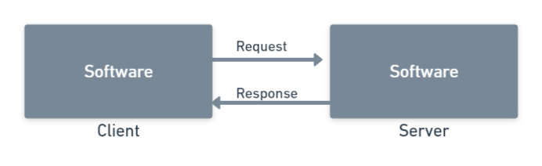

# Control Model

In our project, we use the call-return model where control starts at the top of a subroutine and moves downwards. We choose this model because the app is being developed sequentially so it makes sense to start from the main classes and branch out into subclasses that handle different objectives.

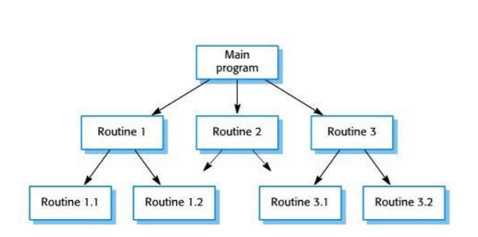

# Class Diagram

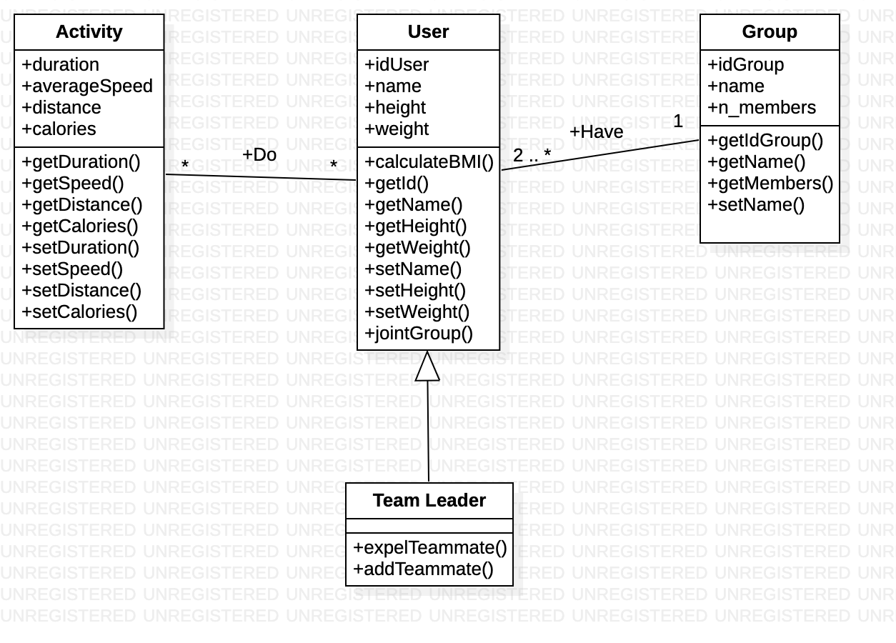

# Activity Diagram

## View profile

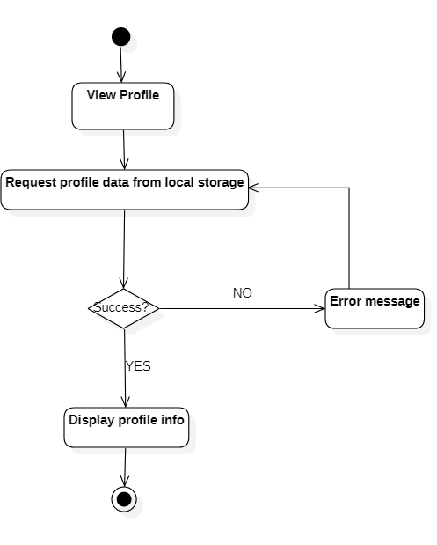

## Change settings

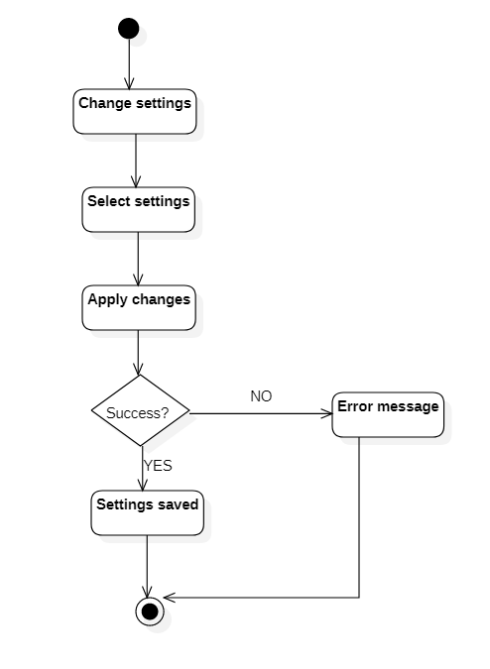

## View past activities

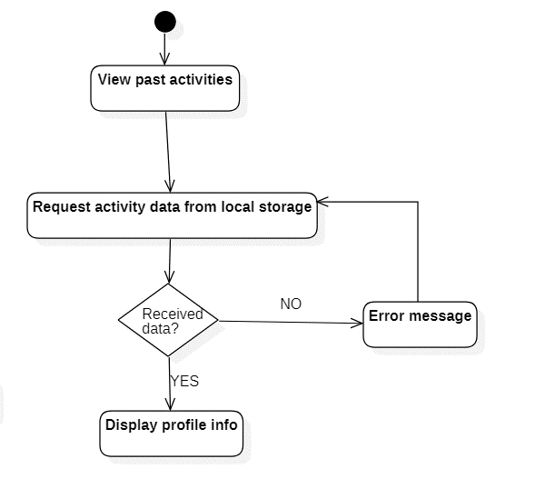

## Start activity

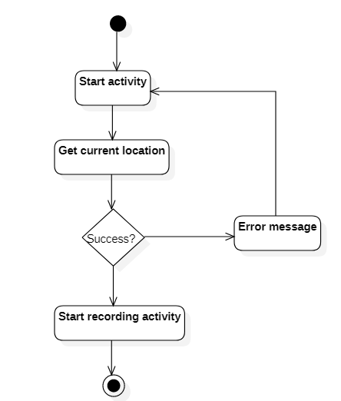

## View activity on the map

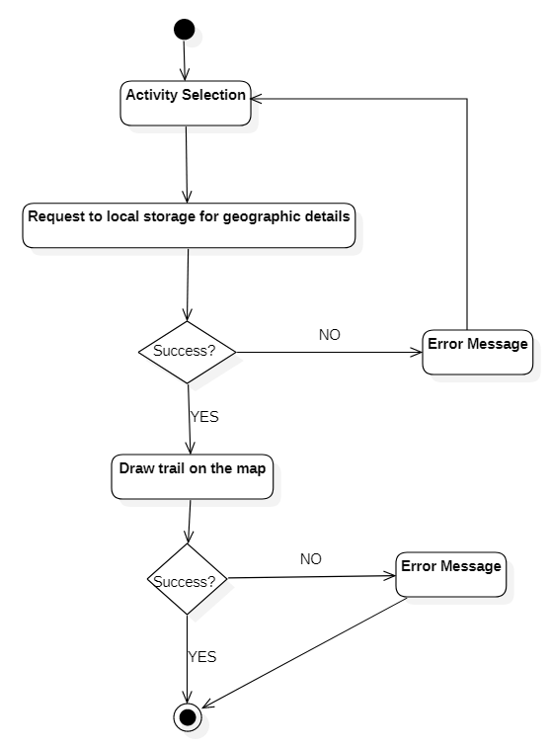

## Join a group

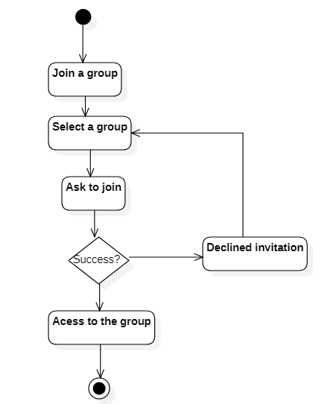

## Make a group

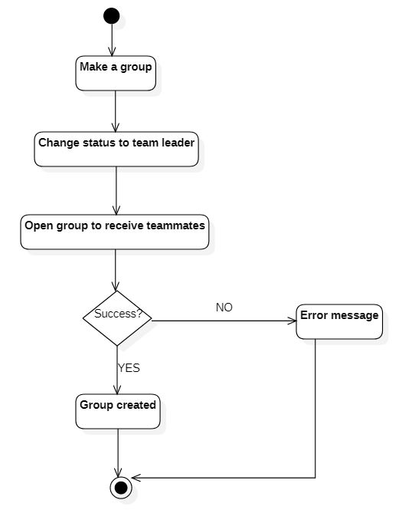

## Leave the group

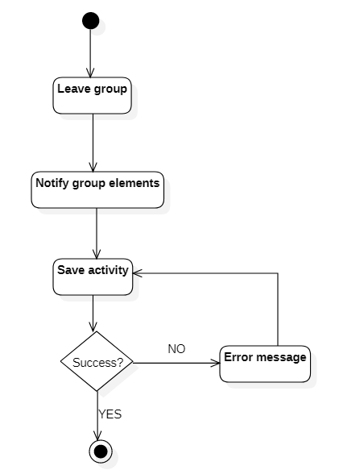

## View teammates account

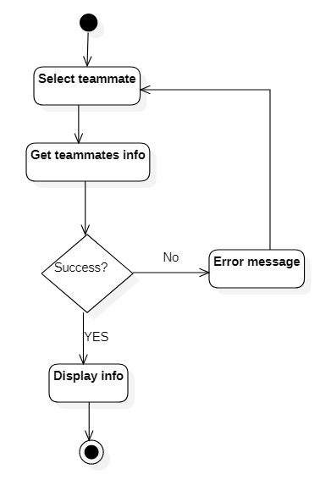

## Expel teammate before activity

## 

## Expel teammate during activity

## 

## Start activity in a group

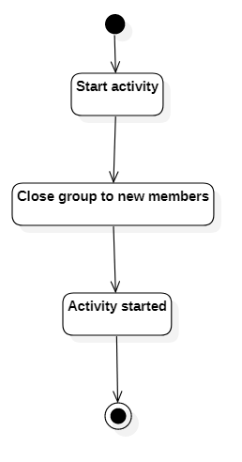

# Sequence Diagram

## Track Exercise

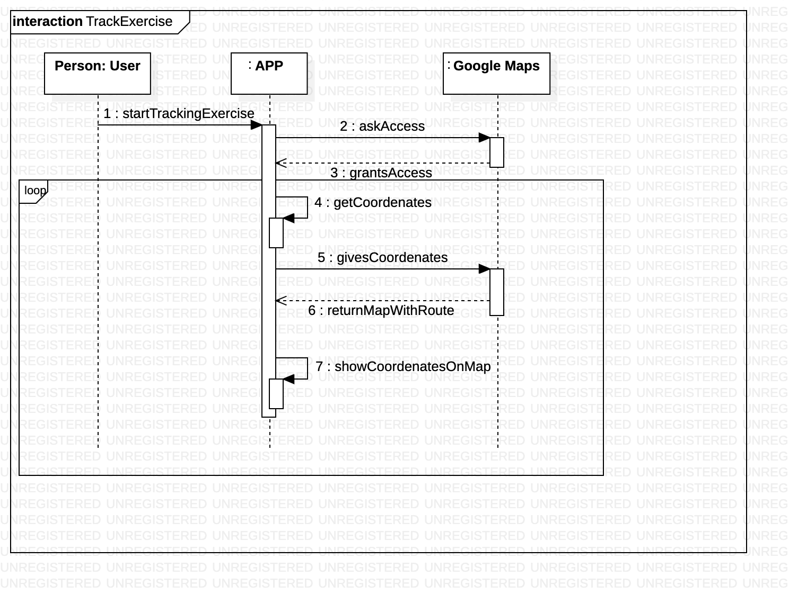

## End Activity

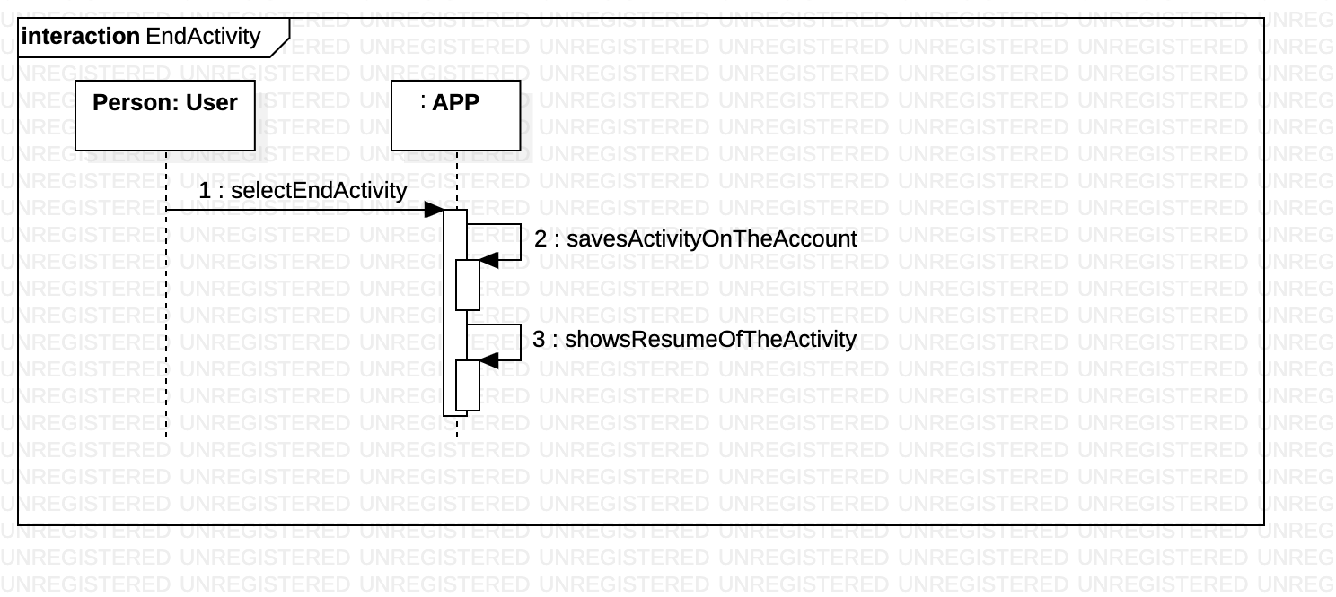

## View Account

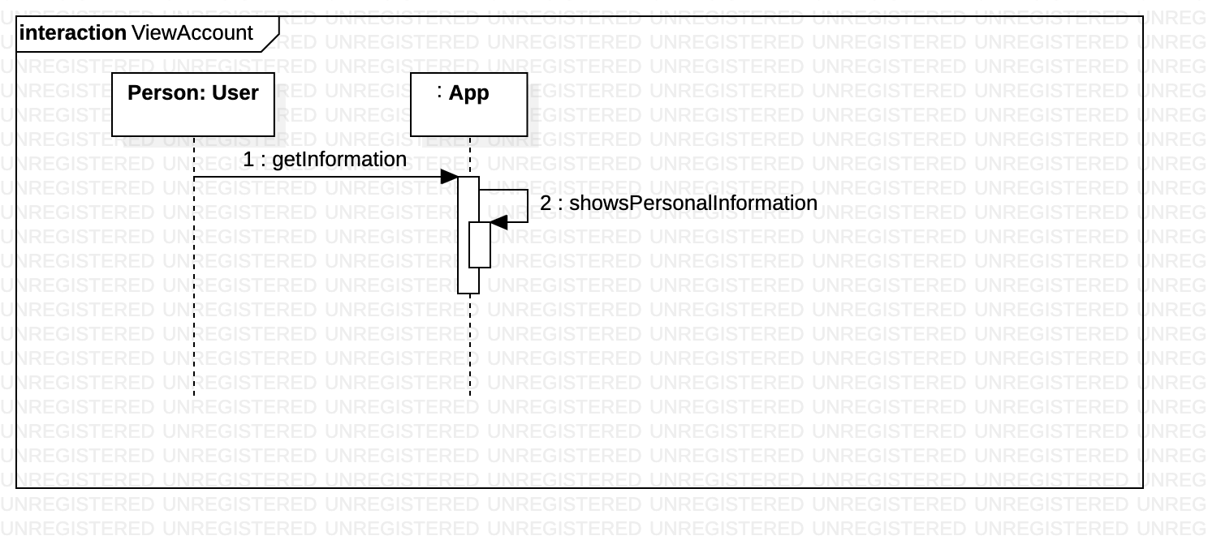

## Activate/Deactivate Features

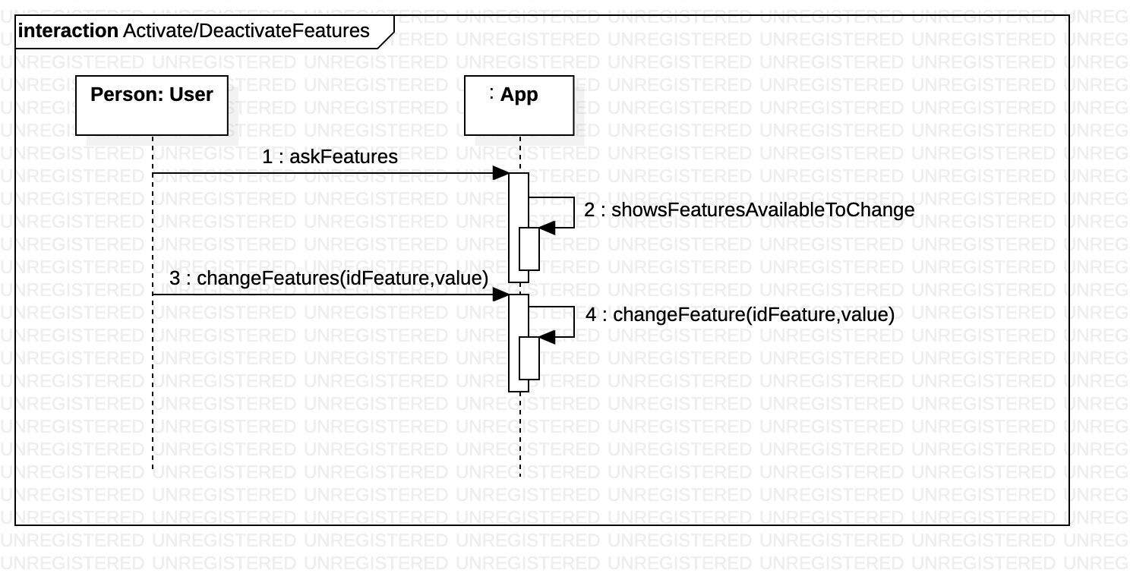

## Make a Group

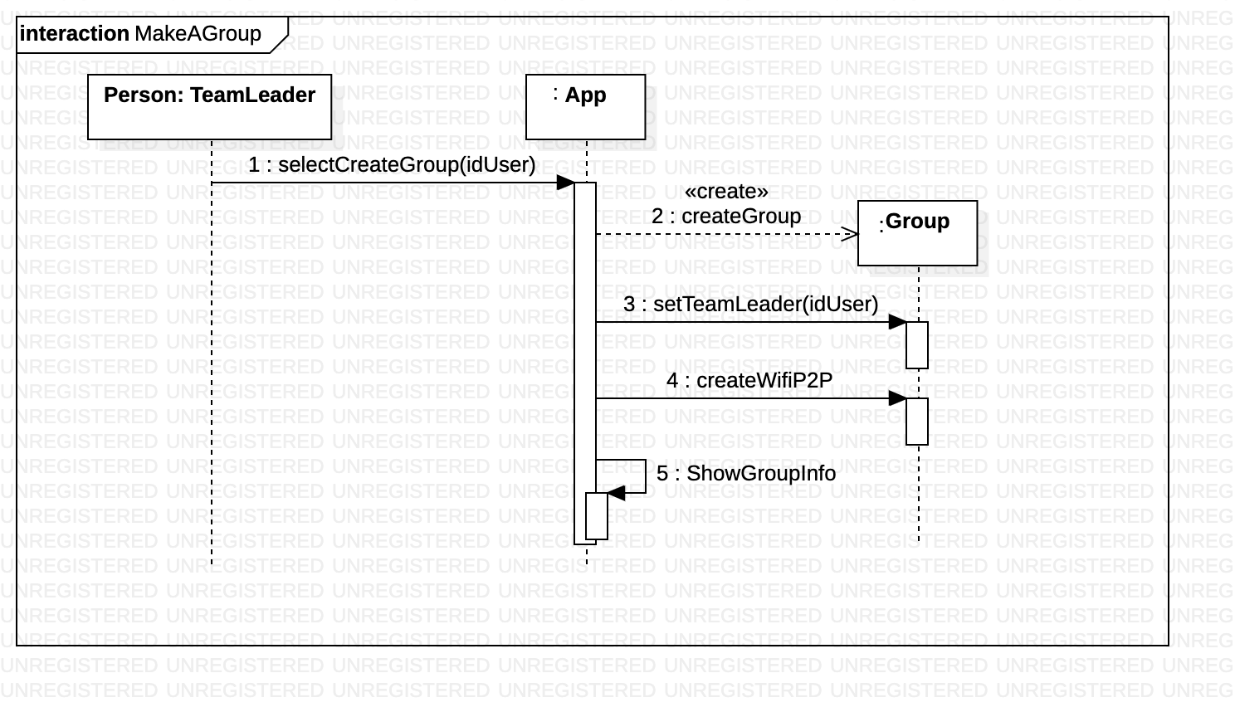

## Join a Group

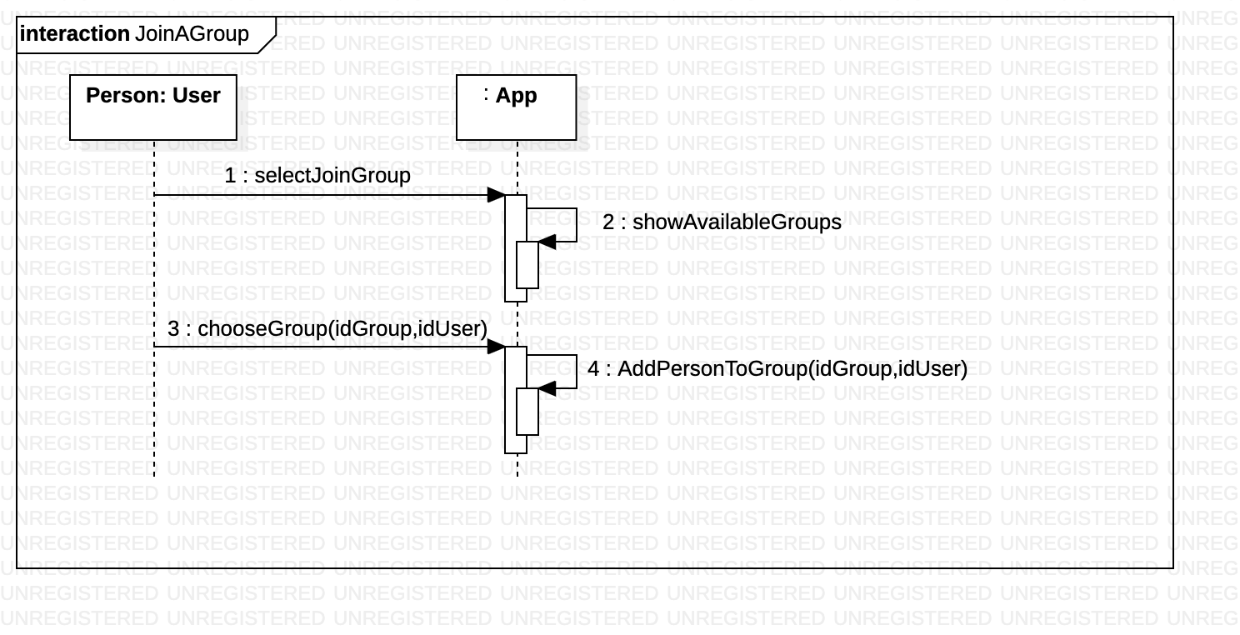

## Leave a Group

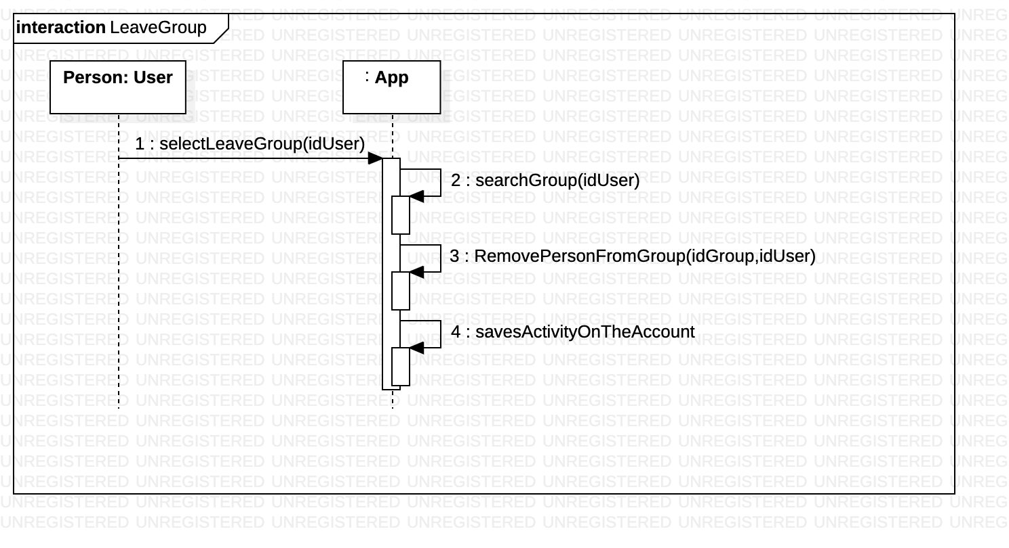

## Add Teammate

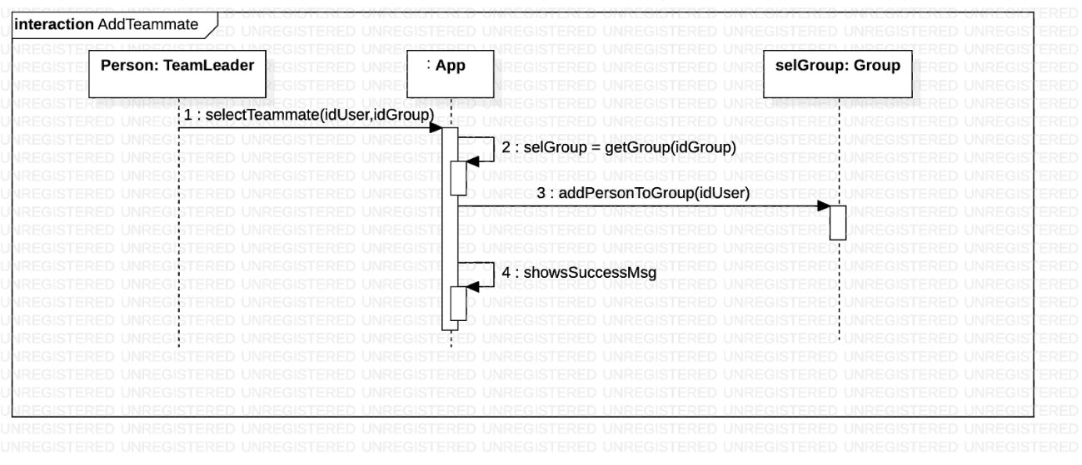

## Expel Teammate before activity

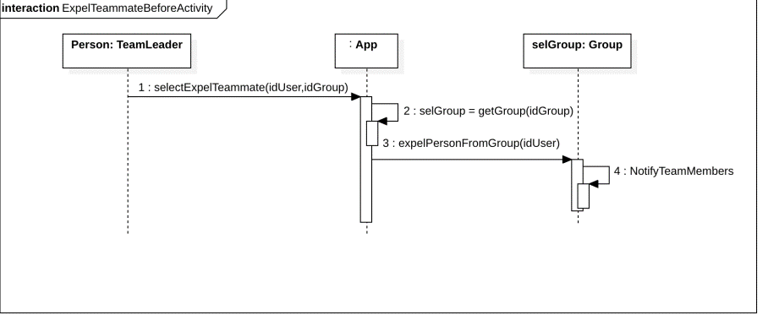

## Expel Teammate during activity

## 

## Consult Past Activities

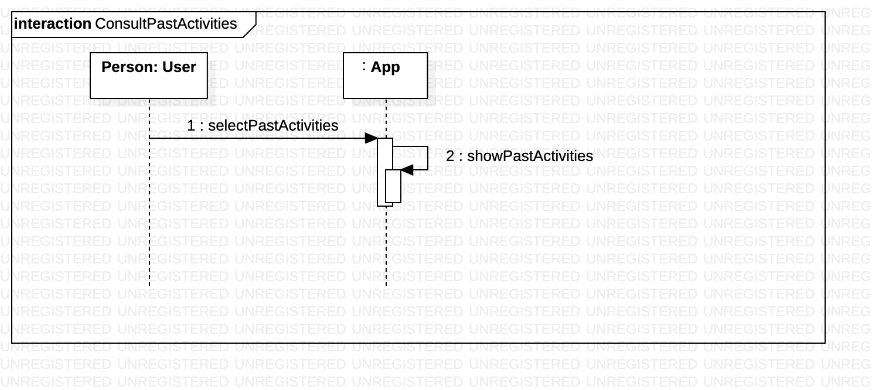

## View Teammate’s Account

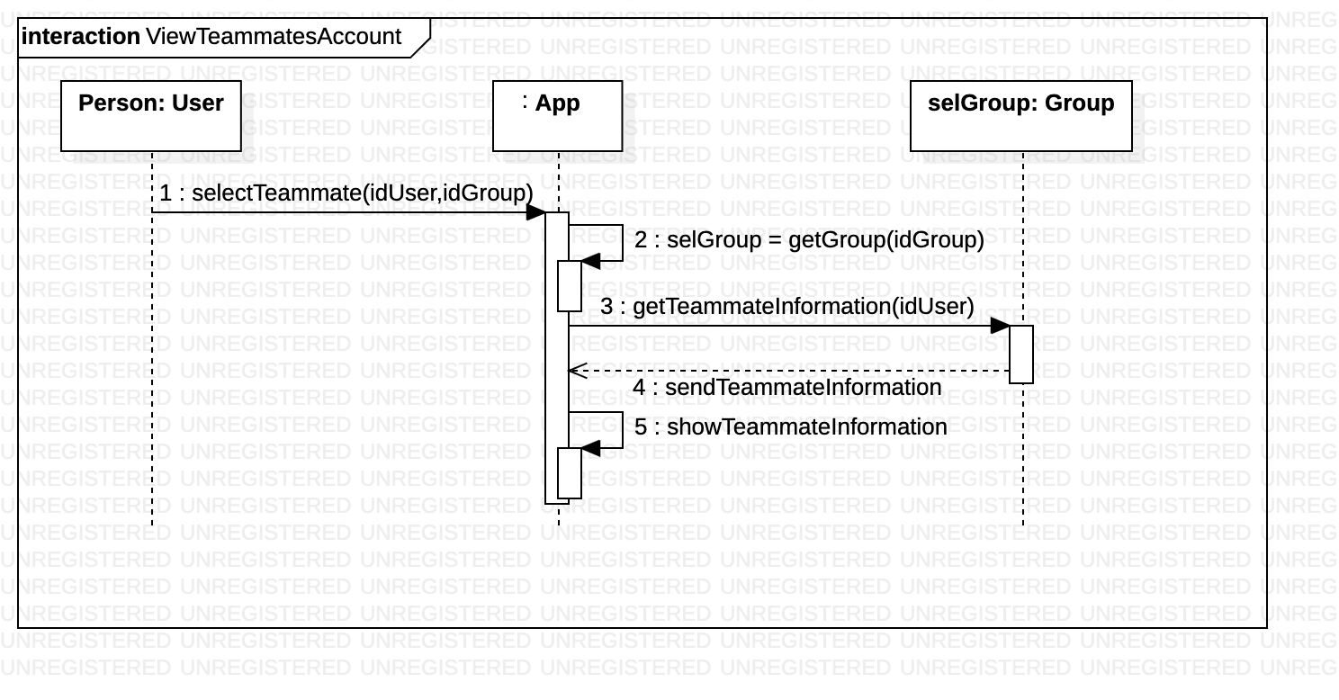

# Graphic Interface

The graphic interface presented below is subject to change until the final product delivery.

## Map options

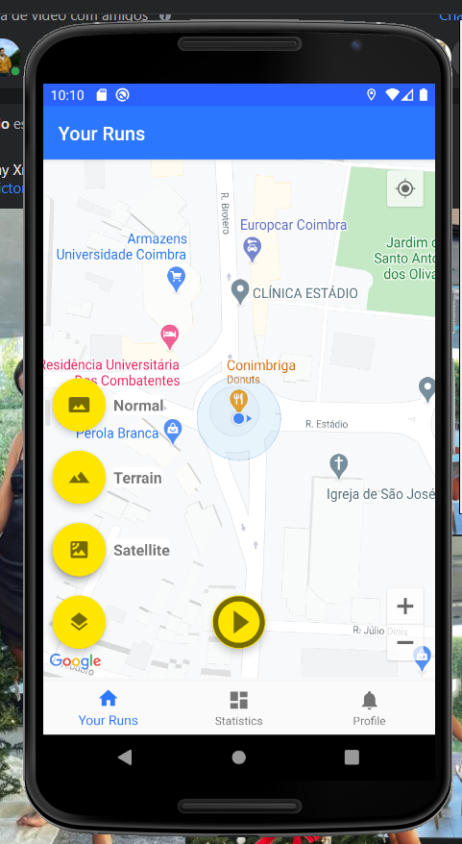

Once on the home screen, the user can choose different styles for the map by clicking on the terrain button which will make the 3 options for the map style appear.

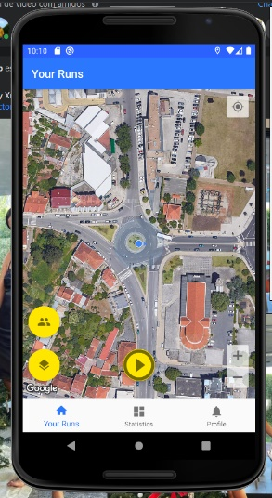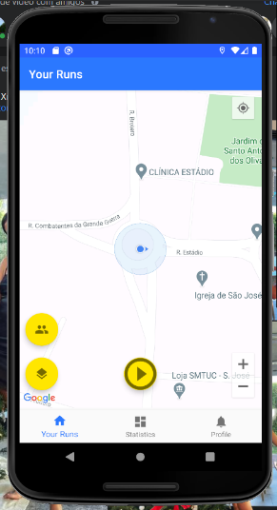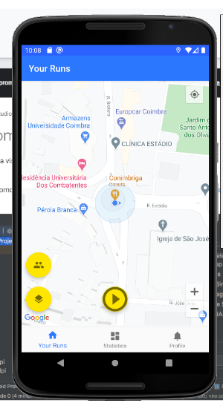

## Group options

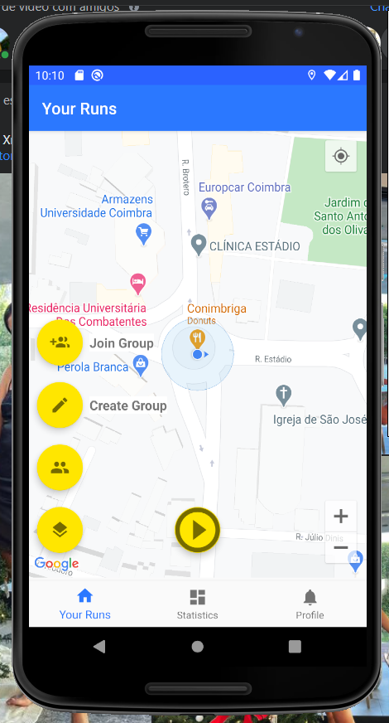

If the user wants to create or enter a group he can click on the second floating button and those options will appear.

## Statistics options



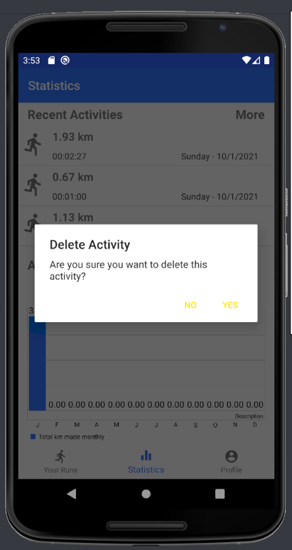In the lower menu if a user wants to see past activities or his annual and monthly statistics he can click on the statistics button and that information will show up.

## Profile

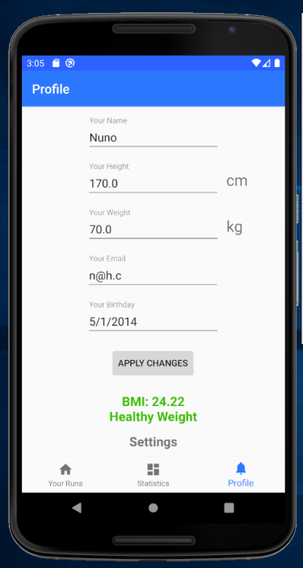

In the lower menu if the user clicks on “Profile” his information can be accessed and changed, in addition to this, he can also click on settings and change settings such as language metric units used in the app.

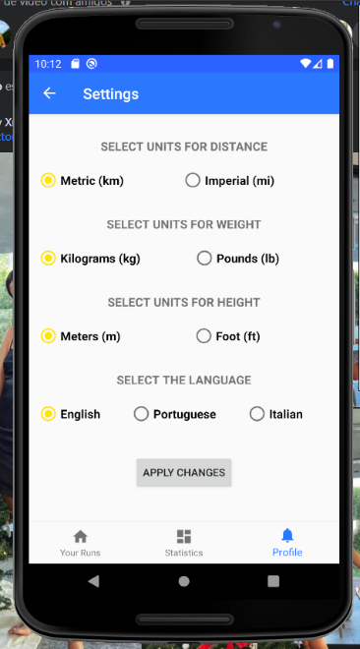

## Make a group

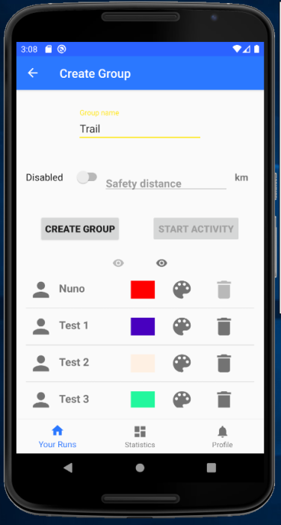

The user can create a group then other people can join, that user then can accept or deny requests to join the group.

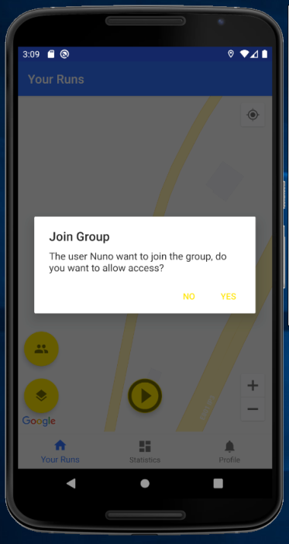

## Join a group

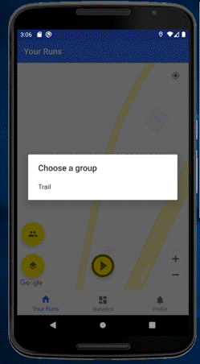

When a user wants to join a group already made the device will show all groups in close vicinity.

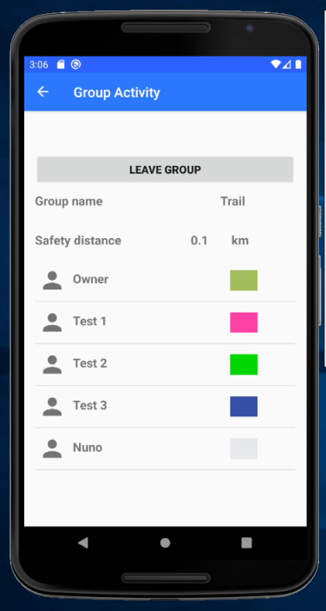

## Group activity

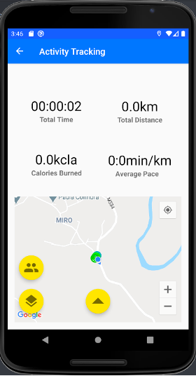

Once in a group, all group members will show on the map with different colours.

## View Teammate’s Account

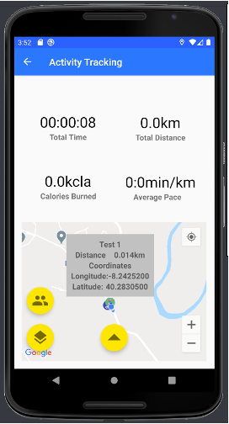

Users can view teammates information by clicking on that teammate on the map.

## Tracking activity



Once an activity has started it will show the time spent, km made, kcal burned, and the average speed of the user. If it's a group activity the map will show the other player’s position.

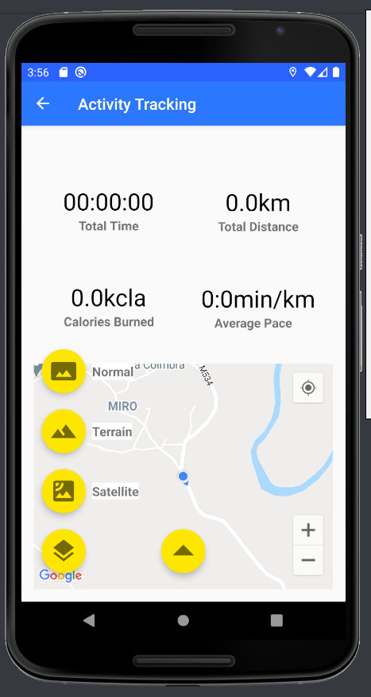

## Mark points of interest

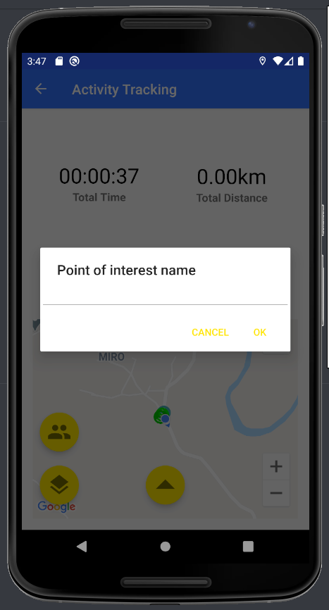

During an activity we can mark points of interest by clicking on the map and introducing the name of the point.

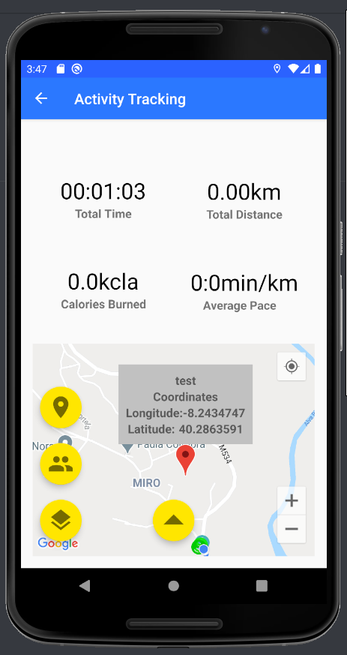

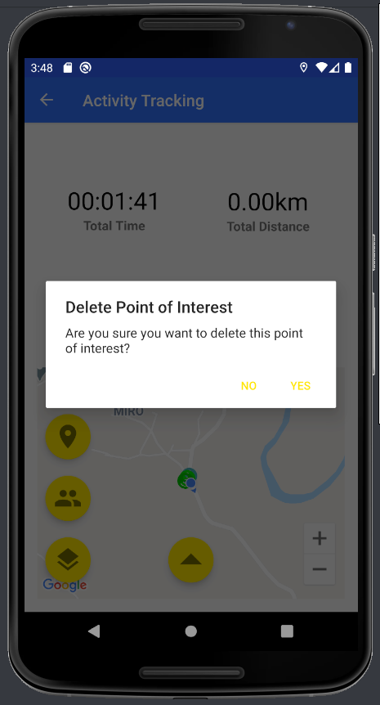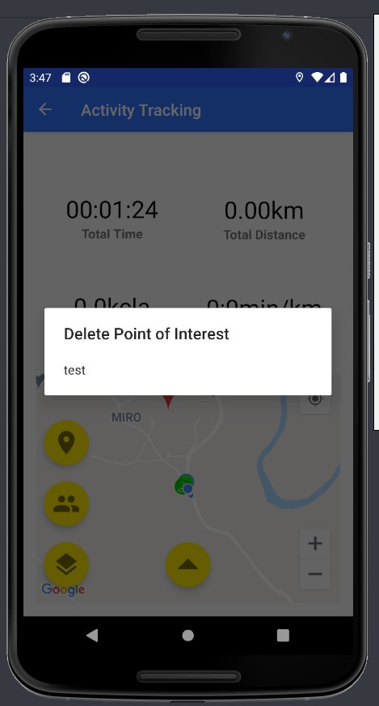

## Expel teammate

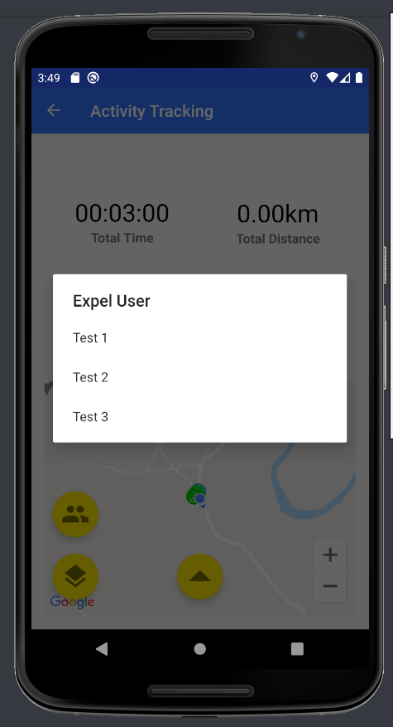During the activity the team leader can expel other teammates.

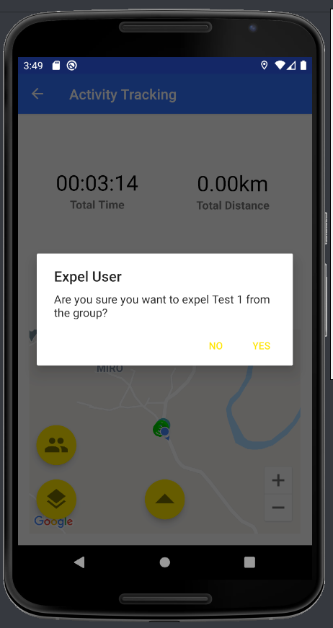

## Leave the group

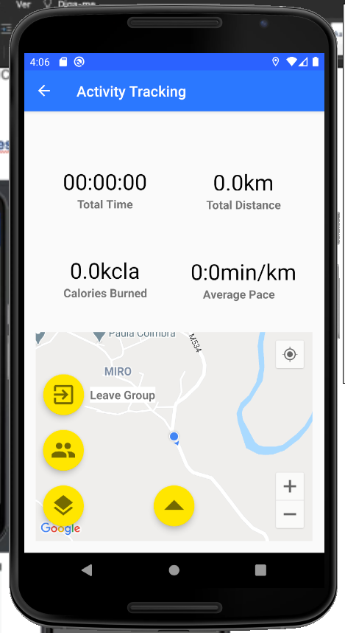

The user can leave the activity group by clicking on the button.

